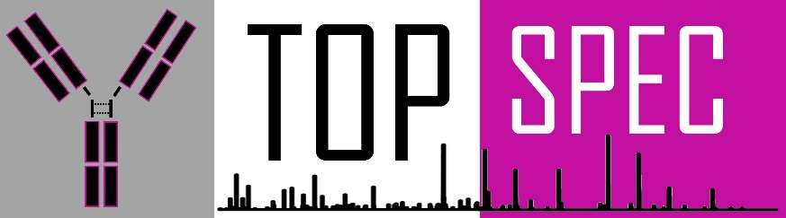

Grant Agreement no: 829157

TopSpec

Project Deliverable Report

D8.2 Draft Exploitation and Dissemination Plan

**Version**: 1.0

**Author**: Remco Swart (MS)

**Contributors**: Susanna Lundström (KI), Jan Commandeur (MS)

**Internal reviewers**: -

**Deliverable due date**: 2019-12-31

**Actual submission date**: 2019-12-xx

**Work package**: WP8

**Task**: T8.2

**Dissemination level**: Public

**Lead beneficiary**: MS

**Status**: Progress

# VERSION AND CONTROLS

|  |  |  |  |
| --- | --- | --- | --- |
| Version | Date | Reason | Editor/ Author/ Reviewer |
| 1.0 | 12 Dec 2019 | First release | Remco Swart |
|  |  |  |  |
|  |  |  |  |
|  |  |  |  |
|  |  |  |  |
|  |  |  |  |

Acknowledgement:

The research leading to these results has received funding from the European Union's Horizon

2020 research programme under grant agreement No. 829157

Disclaimer: This document does not necessarily represent the opinion of the European Commission. Neither the TopSpec Consortium Partners nor the European Commission is responsible for any use that might be made of this document’s content.

The TopSpec logo cannot be used without permission of the TopSpec Consortium Partners. Copyright to this document is retained by the author(s).

# EXECUTIVE SUMMARY

This document provides an overview of the completed and planned dissemination and exploitation activities for the TopSpec project, funded by the European Commission under Horizon 2020 – the Framework Programme for Research and Innovation (2014-2020), Grant Agreement number: 829157

TopSpec is a three-year project that started in January 2019. It aims to develop a ground-breaking TOPdown tandem mass SPECtrometry (MS/MS) platform to solve the challenge of unravelling the sequence repertoire of human antibodies and their respective antigens.

The TopSpec consortium comprises 8 participants from 7 countries who bring together a mix of stakeholder organisations and corresponding expertise. The participants include instrument manufacturers, technology SME’s, universities, and research institutes.

In this document, which is a Deliverable in WP8 titled ‘Dissemination, Communication & Exploitation’, the dissemination and exploitation activities are described.

This report contains Annexes that are indicative of how the dissemination and exploitation are kept track of by the project consortium. Annexes 1 and 3 will be treated as ‘live’ document throughout the duration of the project to reflect the most up to date information and will be accessible from the TopSpec website for all project collaborators.

# CONTENTS

VERSION AND CONTROLS 1

EXECUTIVE SUMMARY 2

CONTENTS 3

1 Project background 4

2 Introduction 5

3 Dissemination of results 6

3.1 TopSpec public website and social media 6

3.2 Scientific presentations 7

3.3 Scientific publications 7

3.4 Conferences 9

3.5 Tradeshows 10

3.6 Patent applications 11

3.7 Collaborations 11

4 Exploitation of results 12

5 Concluding remarks 13

Annex 1 14

Annex 2 15

Annex 3 16

# Project background

TopSpec is a three-year project that started in January 2019. A major and growing challenge in the EU health system is the cost of drugs and targeted therapies. Reducing time taken to develop novel therapies will reduce costs to the health system. To address this grand challenge, it is imperative to better understand how the human organism defends itself against diseases. The biggest mystery is the human immune system; and, understanding this ultimately requires knowledge of the sequence repertoire of human antibodies and their respective antigens.

The purpose of the TopSpec project is to be the first in the world aiming to solve this challenge, opening up opportunities in medical research and drug development that are today only dreamt about. We will create a breakthrough technology that will revolutionize academic, clinical and industrial proteomics and dramatically advance the development of new generation antibody- and protein-based therapeutics.

This complex and ambitious project brings together 8 participants from 7 countries and funded by the European Commission under Horizon 2020 – the Framework Programme for Research and Innovation (2014-2020), Grant Agreement number: 829157.

# Introduction

The Exploitation and Dissemination Plan describes activities that are aimed to i) ensure successful uptake for the TopSpec technologies, ii) integrate all technologies developed in work packages 1-7 into a TopSpec platform and iii) apply the integrated TopSpec platform to model and real-life applications for Abs analysis.

This draft document describes dissemination and exploitation activities that have been completed or are planned for project TopSpec. In the early phase of the project the emphasis is on the dissemination of the project and its results. During the course of the project and with a clear view on the value of the obtained knowledge and technology the exploitation thereof will be addressed. The following type of dissemination activities were taken into consideration:

* TopSpec website and social media
* Scientific presentations
* Scientific publications
* Conferences
* Tradeshows
* Patent applications
* Collaborations

The communication and dissemination of results can be categorized according to the target audience group. In the table below the targeted audience groups are listed and the planned communication/dissemination actions:

|  |  |
| --- | --- |
| **Target groups** | **Communication/Dissemination action** |
| Website | Publicly accessible website with a closed partner access. |
| Proteomics research community | Collaborations, scientific reports. Open access publication in relevant journals: Analytical Chemistry, J American Society for Mass spectrometry, JACS, Molecular & Cellular Proteomics, J of Proteomics, Nature Meth and Nature Biotechnology |
| Young scientists | Young scientists will be encouraged and promoted. Exchange of young researchers will be organised. Summer schools and workshops. |
| Health care providers | Focused meetings to bring technology developers and end users together. Video demonstrations accessible through YouTube and through partner websites |
| Diagnostics and pharma industry | Ongoing collaboration with Amgen, Astra-Zeneca, Bayer, Sanofi, other EU pharma companies. International conferences: Bio, EuPA and HUPO meetings, IMS and ASMS conferences, BIT congresses, PittCon, Analytica. National meetings, CASSS-meetings. |
| General public and broader audience | Information through website, social platforms (Linkedin, Twitter) mass media (newspapers, TV, radio) popular science journals, press releases. Open exhibitions. |

# Dissemination of results

This section describes the activities and tools to communicate and disseminate foreground results of project TopSpec. During the course of the project the available foreground knowledge will increase and thereby also the communication and dissemination activities.

## TopSpec public website and social media

Under WP8 a project webpage (<https://topspec.ki.se/>) has been designed and launched. The TopSpec website contains current information related to the project, news, obtained results and organized/attended events and will be updated on a regular base. Further is contains the following information:

* Description of project
* Individual workpackages
* Public documents
* Objectives and milestones
* Profile of researchers and project partners
* Events related to the project implementation

The project webpage contains the following clause: “This project is funded by the European Horizon 2020 research and innovation program under grant agreement no 829157.” The website is actively maintained and updated using materials from events organized by the collaboration partners, delivered lectures, workshops. All reports that have the “PUBLIC” status can also be found on the webpage.

To make the project more visible a logo of the project has been designed and uploaded to the project webpage. This logo will be used in all public communication activities (tradeshows, presentations).

The TopSpec webpage is regularly updated and up to now 6 news items have been published. Up to this date the project webpage has been visited by x visitors.

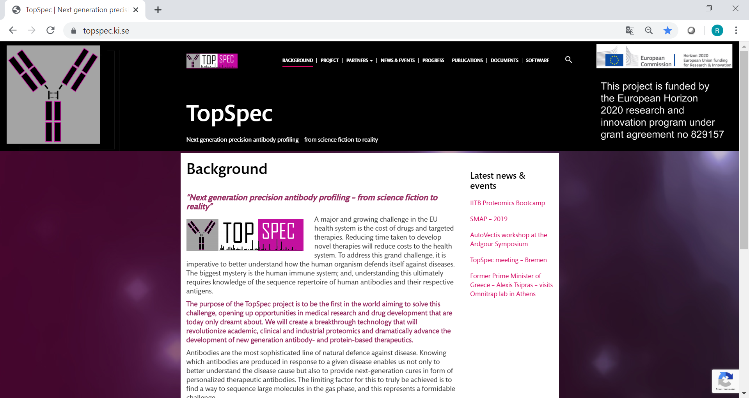

Besides the website, a Twitter and a LinkedIn project account have been created with the following links:

<https://twitter.com/TopSpecMS2>

<https://www.linkedin.com/company/topspecms/>

## Scientific presentations

The following scientific presentations have been delivered by the TopSpec collaboration partners

* A
* B
* C

## Scientific publications

Result obtained in the TopSpec project will be published in scientific journals in the field of analytical chemistry. In case technology requires patent protection the publication cycle may be delayed. The articles will be published in open access publication in relevant journals:

* Analytical Chemistry,
* J American Society for Mass spectrometry,
* JACS
* Molecular & Cellular Proteomics
* J of Proteomics,
* Nature Meth
* Nature Biotechnology

Among others, the following topics are planned to be researched and prepared for publication:

* …

Publications will consist of the clause in the acknowledgements section:

“This project is funded by the European Horizon 2020 research and innovation program under grant agreement no 829157.”

Pulications will also be listed on the TopSpec homepage.

## Conferences

The results and data from project TopSpec will be presented at industrial and academic conferences, user meetings, immunology, proteomics and MS conferences. This section describes some of the recent conferences that have been visited by TopSpec project partners.

*SMAP 2019*

“De Spectrométrie de Masse et Analyse Protéomique” (SMAP) is the annual French mass spectrometry society meeting with up to 350 participants from academia and industry. The meeting is a great opportunity for interdisciplinary networking across different fields with mass spectrometry as the common denominator. Mathieu Dupre (IP) peaked interest in TopSpec following his presentation. See Mathieu Dupre below.

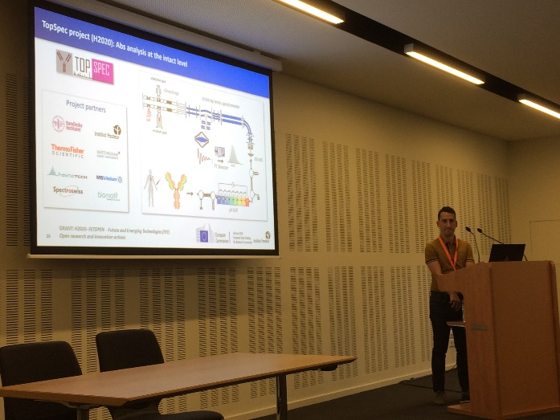

*2019 EMSG Ardgour Symposium*

David Kilgour (TNTU), presented the latest features and upgrades of AutoVectis v9 (part of WP7), at the 2019 EMSG Ardgour Symposium, in the beautiful Peak district, UK. The Ardgour Symposium is an interdisciplinary scientific meeting centered around the users and developers of scientific instrumentation. The Symposium structure has been refined over the years to provide an environment that is designed to foster the development of new productive networks. The meeting was attended by 20 scientists from across Europe (countries and nationalities represented: Italy, Netherlands, France, Germany, Romania, Hungary, Sweden and the UK) and the wider world (USA and India) and had a mixture of scientific sessions, group networking sessions, workshops and free discussion time. In addition to David, Susanna Lundström (KI) attended the meeting and gave a presentation with the title “MS analysis of polyclonal antibodies – the ultimate challenge and reward”. Both David and Susanna acknowledged TopSpec and the European Horizon 2020 research and innovation program under grant agreement no 829157. The TopSpec project was discussed and the webpage was also advertised during the meeting.

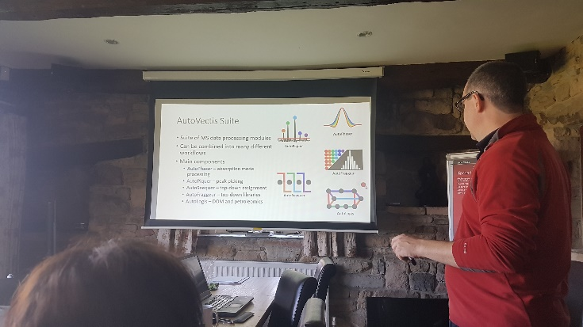

*IITB Proteomics Bootcamp*

David Kilgour (TNTU) travelled to the Indian Institute of Technology Bombay, Mumbai, India, to teach as part of the international faculty at the IITB Proteomics Bootcamp: “Basic and Advanced Proteomics Techniques – Omics Technologies for Life Sciences”. This two week long course focused on:

* Proteomics: basic and advanced technologies,
* Other ‘omics technologies – genomics, metabolomics etc
* Big data analysis and bioinformatics
* and, included a mixture of lectures, hands-on workshops and tutorials.

It was aimed at life science and medical researchers. Overall, there were more than 50 attendees, who came from across India. The faculty included lecturers from the UK, India and the US.

Dr Kilgour gave lectures on electrospray ionisation, basic Fourier transform mass spectrometry concepts, and an introduction to absorption mode FTMS data processing. The TopSpec project was discussed specifically as an example of the future direction and cutting edge of protein analysis in biomedical research.

The following international conferences will be visited to present results from the TopSpec project:

* Bio
* EuPA
* HUPO meetings
* IMSC
* ASMS
* BIT
* National mass spectrometry and biopharma meetings
* CASS-meetings

## Tradeshows

Dissemination of foreground results at fairs and international tradeshows such as Analytica and Pittcon is planned. In order to promote the TopSpec project among the scientific community at conferences and meetings we have created a banner, see annex 2.

## Patent applications

In the course of the project it is expected that foreground knowledge will be generated. The project consortium will strive to obtain patent protection of inventions/solutions which may result in business opportunities taken up by one or more collaboration partners. The IP strategy as well as the dissemination of foreground knowledge has been detailed described in deliverable D8.1 TopSpec Intellectual Property Protection Strategy.

Similar to other results of the TopSpec project, patent applications should consist of the following clause in the acknowledgements section: “This project is funded by the European Horizon 2020 research and innovation program under grant agreement no 829157.”

## Collaborations

It is expected that the obtained technology is of utmost importance to researchers that are tasked to identify protein structures and interactions. In order to access the potential of the technology we will organize a demonstration workshop. Stakeholders will be invited to analyze project results in order to evaluate the scientific relevance, performance and transferability of the technology. Existing research partners in industry and academia will be invited to this workshop: the Swedish National Centre for Biological Mass Spectrometry (Bio-MS); the Proteomics centre of the Copenhagen University (Prof. Michael Nielsen); Proteomics centre, University of Southern Denmark, Odense (Prof. Frank Kjeldsen); Protein analysis laboratory of Novo Nordisk AS, Copenhagen (Dr. Kim Haselmann); Protein analysis laboratory of Amgen (Dr. Pavel Bondarenko); Proteomics laboratory of Harvard University, FAS Division of Science Core Facility (Dr. Bogdan Budnik); Proteomics laboratory of Stanford University (Dr. Chris Adams); Top-down protein analysis laboratory of Innsbruck University, Austria (Dr. Kathrin Breuker); NIH-supported glycoproteomics laboratory at Boston University (Prof. Catherine Costello).

# Exploitation of results

The objective of TopSpec project to develop a ground-breaking top-down tandem mass spectrometry platform to solve the challenge of unravelling the sequence repertoire of human antibodies and their respective antigens. Thus, the activities within the project will require tools to be developed by the participants and/or third parties and then integrated into a comprehensive and customised platform. If successful, TopSpec will greatly expand our knowledge of the human immune system, which may have a dramatic impact on the field of personalized, precision medicine. TopSpec may facilitate the development of new diagnostics and treatments for infectious diseases including global diseases and the problem of treatment resistance, ageing related diseases (e.g., AD) and other big killer diseases. Another significant impact will be in the field of MS instrument design. Specific impacts:

• Increase in the speed of diagnosis and in the speed of drug development

• Increase knowledge on an individual´s antibody response to disease

• Contribute to the growth and expansion of 4 European SMEs

• Expand scientific research around proteomics

• Create new business opportunities within and outside the project

Expected results from the TopSpec project are summarized in the table below:

|  |  |  |  |
| --- | --- | --- | --- |
| **Expected Result** | **Target Industry** | **Use within the project** | **Use outside the project** |
| Novel MS/MS platform | MS  instrumentation | Adopted by TF | Adopted by other MS manufacturers |
| Top-down Ab sequencing assay | Biotechnology, Clinical diagnostics | Proof of principle, biomarkers of AD and bacterial infection | Quality control in mAb production, biosimilars and biobetters, clinical diagnostics |
| Library of Ab repertoire as immune system response to  challenge | Immunology, Bioinformatics | Proof of principle | Large EU projects to collect Ab sequence libraries for specific diseases |
| Top-down data analysis software | Analytical, biotechnology, pharmaceutical | Proof of principle | Open source and commercial versions for industrial and academic analytical scientists |
| Novel data acquisition and realtime data processing system | MS  instrumentation | Adopted by Spectroswiss | Adopted by other MS manufacturers, including TF |

The project partners are keen to bring the technology to the market. This can be as a complete LC-MS platform for antibody sequencing including hardware, software and consumables. Also the possibility to commercialize parts of the developed technology will be explored. The strategy to commercialize products and services will be discussed in a dedicated workshop with TopSpec project partners.

Based on the market potential of the foreground technology and it’s application a detailed business strategy document will be prepared and published (CONFIDENTIAL) for the consortium partners, detailing the market size and potential. See for more details task 8.7 in annex 3.

# Concluding remarks

This deliverable provides a draft plan for communication, dissemination and exploitation of the foreground results. During the course of the project and the maturation of technology the dissemination and exploitation plan will be updated. The leader of WP 8 has the responsibility to manage WP8 and the planned deliverables.

This report contains Annexes (1+3) that will be treated as ‘live’ documents throughout the duration of the project to reflect the most up-to-date information.

# Annex 1

TopSpec Consortium exploitation and dissemination activity tracker

(To be kept updated)

|  |  |  |  |  |  |  |  |  |  |  |  |
| --- | --- | --- | --- | --- | --- | --- | --- | --- | --- | --- | --- |
| **Person** | **Institution** | **Activity** | **Type of activity** | **Status** | **Result** | **Date of completion** | **Comments** | **Link (DOI)** | **Deliverable** | **Impact** | **WP** |
|  |  |  |  |  |  |  |  |  |  |  |  |
|  |  |  |  |  |  |  |  |  |  |  |  |
|  |  |  |  |  |  |  |  |  |  |  |  |
|  |  |  |  |  |  |  |  |  |  |  |  |
|  |  |  |  |  |  |  |  |  |  |  |  |
|  |  |  |  |  |  |  |  |  |  |  |  |
|  |  |  |  |  |  |  |  |  |  |  |  |
|  |  |  |  |  |  |  |  |  |  |  |  |
|  |  |  |  |  |  |  |  |  |  |  |  |
|  |  |  |  |  |  |  |  |  |  |  |  |

# Annex 2

TopSpec Consortium banner for display at conferences

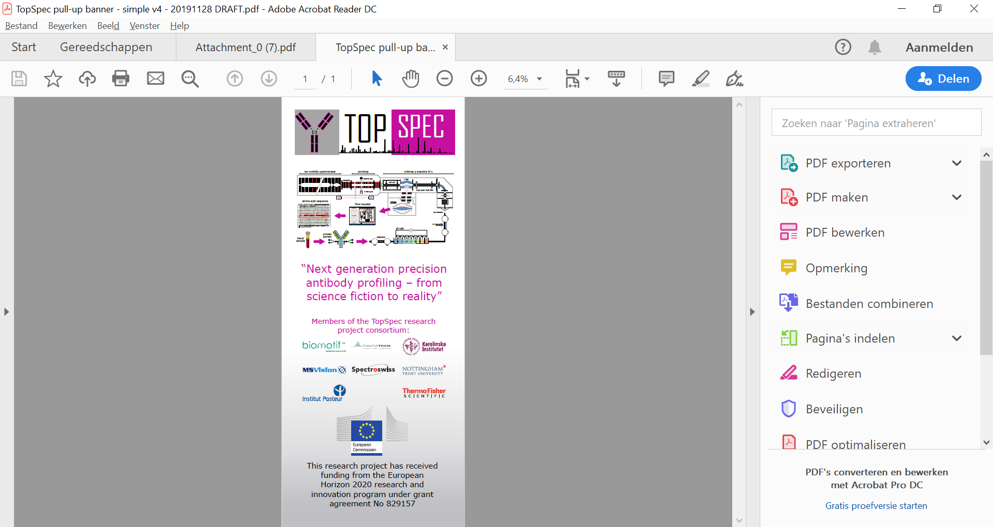

# Annex 3

Overview of WP 8 – Dissemination, communication and exploitation of results

|  |  |  |
| --- | --- | --- |
| **Task** | **Activity** | **Period** |
| **8.1** | **Dissemination activities**   * Creating and publishing the public dissemination material (Website, posters, brochures, videos), * Adapting the dissemination support to the target, * keeping track of publications and public disclosures by creating a database. | M1-36 |
| **8.2** | **Knowledge Management and IPR**   * Management of the pre-existing knowledge needed to achieve the work (background), the knowledge created duringthe project (foreground), and the knowledge created in parallel to the project (side-ground) by either partners or other parties that might impact the project. | M1-36 |
| **8.3** | **Exploitation strategy of the results**   * Identification of the internal and external stockholders. * Determining the synergies between them to integrate the results, identify the weak points, assess the usability of theresults. * Identify the competing technical approaches * Analyze the evolving socio-economic context including user needs, overall market trends. | M1-36 |
| **8.4** | **Demonstration workshop**   * The stakeholders identified and presented in 8.3 will be invited to analyze project results in order to evaluate the scientific relevance, performance and transferability of the technology. | M22 |
| **8.5** | **Management of patent strategy and freedom to operate (FTO)**   * Develop an IP protection strategy at the start of the project (M3). * Monitor that the newly created IP falls under the Consortium Agreement. | M1-36 |
| **8.6** | **Public engagement**   * Create articles with easy public access through project website * Publish popular articles in general science magazines * Giving interviews to news reporters (newspapers, TV, radio etc.) | M1-36 |
| **8.7** | **Develop and implement a common business strategy for market introduction**   * Develop a common business strategy for market introduction through consultations within Consortium. * Implement the developed business strategy for market introduction. | M12-36 |
| **8.9** | **Organizing relevant conferences**   * Organizing a conference of the UppCon series (Uppsala conference on Electron Capture Dissociation and relatedphenomena, run since 2003). * Organizing a conference on Top-down analysis of proteins; * Organizing a summer school on Electron Capture Dissociation and related phenomena Top-down analysis of proteins,as part of the annual MSBM (MS in biotechnology and medicine) summer school in Dubrovnik, Croatia. * Organizing hands-on course will be arranged at KI, and will be open to European students. | M6-36 |
| **8.10** | **Communication to commercial research organizations**   * As we anticipate significant interest in TopSpec from the Pharma industry, we will act through technical mediachannels, B2B, fairs and conferences. | M12-36 |